CHARLTONS PRESCHOOL TOPIC KNOWLEDGE ORGANISER Spring 1B 2024
Topic: Weather |  | I know that: Weather changes
Key vocabulary |  | Sticky knowledge  - Know the order of seasons  - Know that weather changes within each season
- Weather  - Seasons  - Cold  - Hot  - clouds | - Sun  - Rain  - Snow  - Ice  - frosty
Key text |  | Enrichment Opportunities
Guess how much I love you – Spring, summer, Autumn, Winter  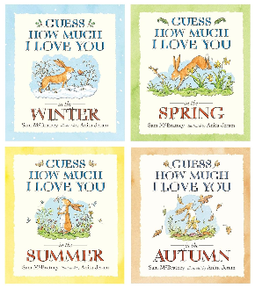 | Seasons come, seasons go (tree book)  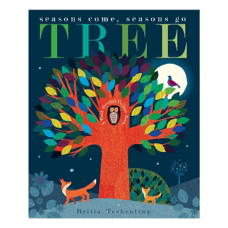 | - Outdoor play/exploration  - Weather bottles  - Walk to local environment
Songs and Rhymes

- CD – Songs for around the year
- 22 – The rain song
- 29 – let it snow
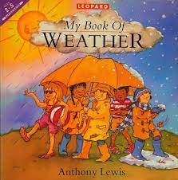  My book of weather – Anthony Lewis | Rosa explores the water cycle  